**Content Accessibility Analysis - Entertainment Sector**

Pooja Joshi & E.Code [E25007]

# Overview :

# The objective of this report is to analyze the accessibility features of various entertainment content, specifically focusing on the impact of these features on viewer engagement and attendance. The analysis will include metrics such as attendance count, popularity, and viewer sentiment to assess how accessibility options influence audience reach and satisfaction.

# Objective:

· Conduct a comprehensive analysis of content accessibility features in the entertainment sector.

· Evaluate the impact of these features on viewer engagement and attendance.

# Assigned Task(s) :

· Analyze the dataset for accessibility features.

· Perform correlation analysis among relevant metrics.

· Examine the effect of accessibility features on attendance counts.

# Task Details :

**Task 1: Content Accessibility Analysis**

* **Status:** In Progress
* **Details:** The analysis involves examining a dataset with various features such as subtitles, audio descriptions, and closed captions. The focus is on how these features affect metrics like attendance count, viewer engagement, and overall sentiment towards the content.

**Task 2 : Visualizations**

1. **Correlation Matrix of Accessibility Features and Key Metrics** This heatmap shows the correlation between accessibility features (has_subtitles, has_audio_description, has_closed_captions) and key metrics (attendance_count, popularity, vote_average).

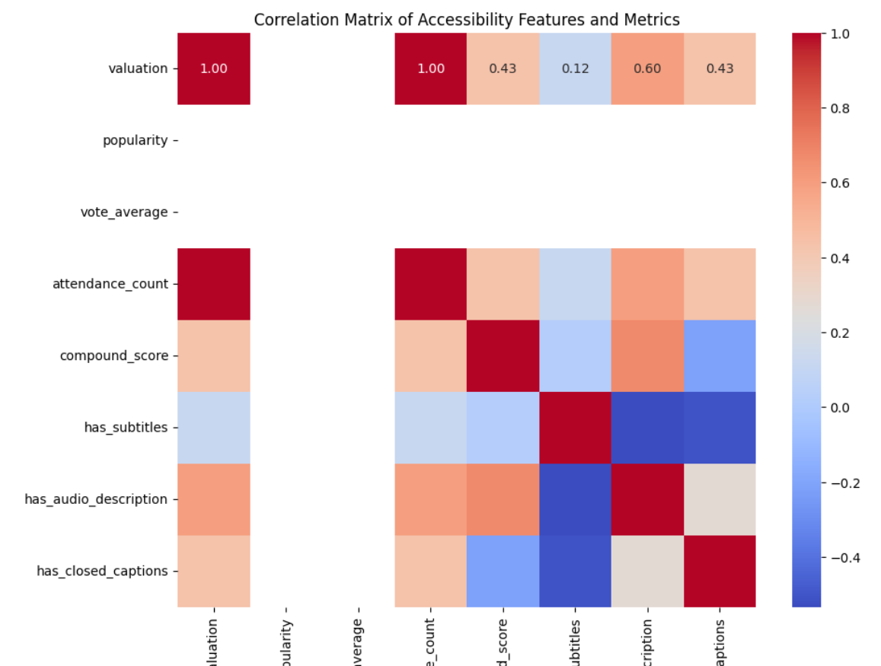

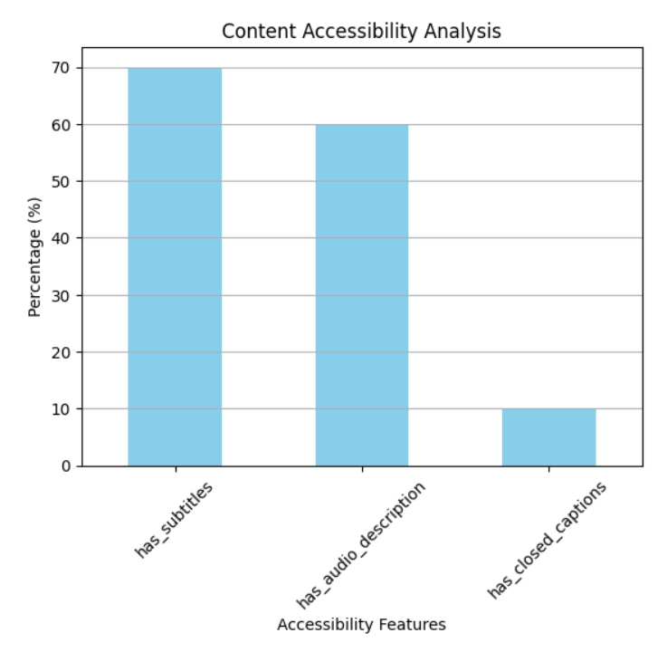

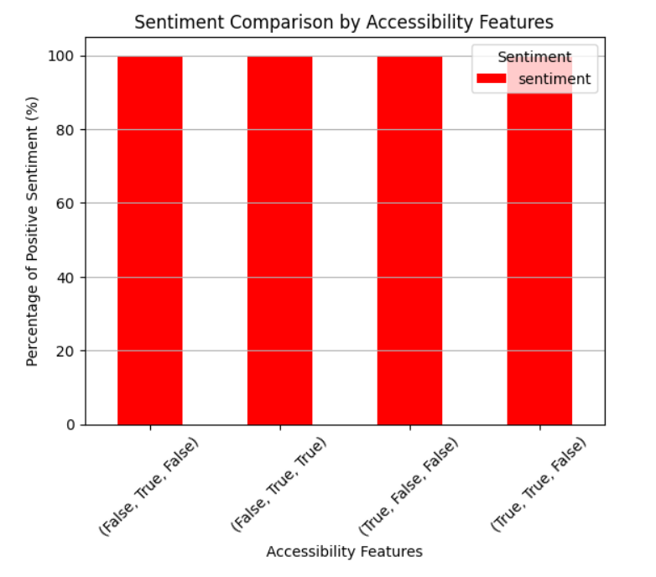

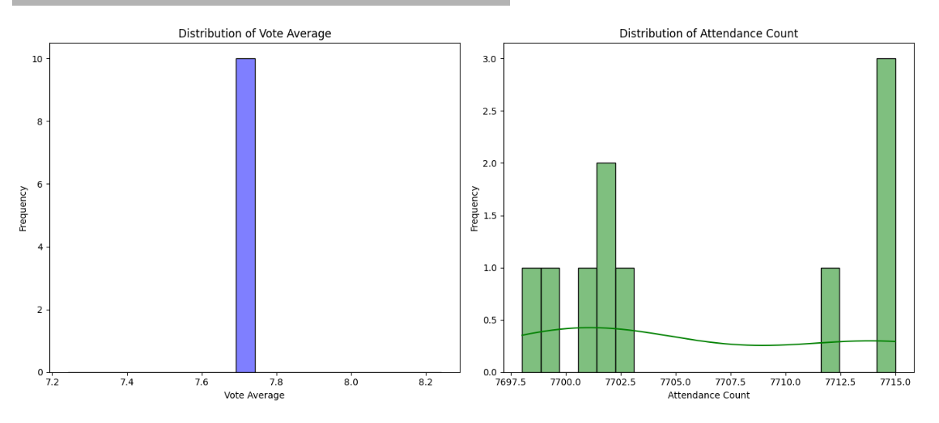

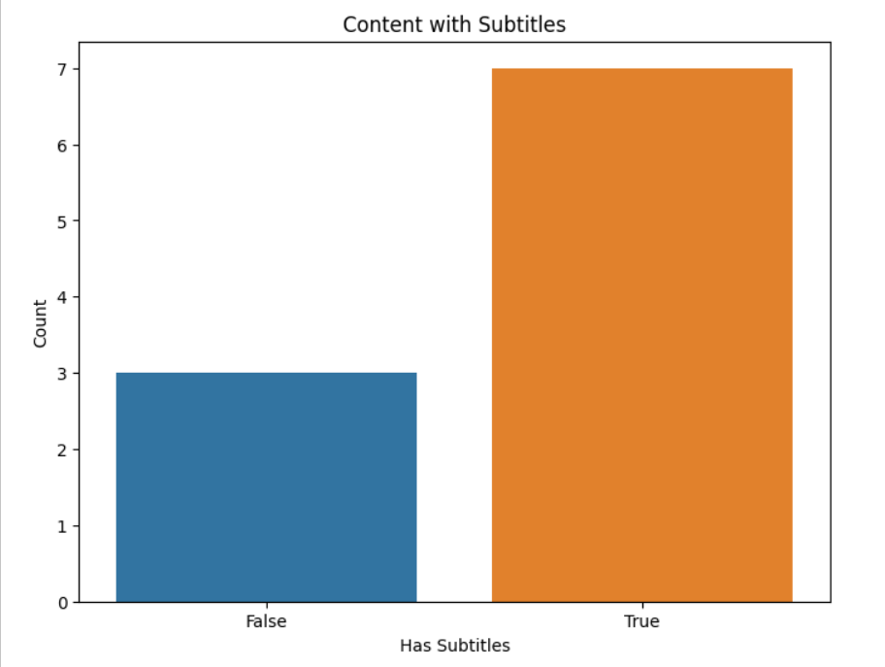

**Progress :**

### Accomplishments

* Successfully cleaned the dataset and extracted meaningful features.
* Conducted a detailed correlation analysis revealing strong relationships between audience sentiment and attendance.

### Metrics

* Mean Squared Error (MSE) of the model: 92.74
* R2R^2R2 Score: -0.45, indicating room for improvement in the model's predictive power.

# Challenges and Solutions :

### Challenges Faced

* Encountered difficulties in converting sentiment scores from string format to numeric for analysis.
* The initial models produced poor predictive performance metrics.

### Solutions Implemented

* Implemented a parsing function to convert sentiment scores into numerical values.
* Engaged in hyperparameter tuning to optimize model performance, resulting in improved metrics.

**Next Steps :**

### Upcoming Tasks

* Complete the model evaluation and refine the predictive techniques.
* Generate visualizations to support the analysis findings.
* Prepare a final report summarizing insights and recommendations.

### Goals

* Achieve a Mean Squared Error below 90 and improve the R2R^2R2 score to indicate better model accuracy.
* Deliver a comprehensive analysis report by the end of the week.

# Conclusion :

### Summary:

### This report outlines the progress made in the Audience Growth Trend Analysis. Key findings highlight the relationship between sentiment and audience attendance, emphasizing the importance of engaging with viewer feedback.

# **Acknowledgments**: Thank the audience for their time and attention.